Assessment Evidence Guide
For
“PLUMBER”
LEVEL-3
Formative Assessment
0732BCE1606 Install Solar Water Heating System
Date 04-09 November, 2024
Lahore


National Vocational & Technical
Training Commission

Instruction Sheet for the Candidate
Qualification | PLUMBER LEVEL-3
Competency Standard | 0732BCE1606 Install Solar Water Heating System
Purpose of Assessment | Formative Assessment
Candidate Details | Name______________________________________________________  Registration/Roll Number_______________________________________
Guidance for Candidate | To meet this standard, you are required to complete the following within 04 Hrs. time frame (for practical demonstration & assessment):  - Install domestic solar water heater according to instructions  - Install supply lines for solar water heater  - Maintain solar water heater  ACTIVITY  - Assemble the solar water heating system and install for domestic purpose, joint the outlet point for general use according to the given drawing. (Annex 1)
Time: 4 Hrs. | During a practical assessment, under observation by an assessor, you are required to
Minimum Evidence Required | - Perform all safety checks and wear appropriate PPEs.  - Perform estimation of household's hot water consumption  - Select the appropriate tools as per job requirements  - Measure, cut, and join pipes as per installation layout  - Connect solar collector and frame according to instructions  - Position the solar collector and connect to the storage tank.  - Ensure the solar water heater is installed at an angle that maximizes sun exposure  - Install essential sanitary accessories, including solenoid valves and connectors  - Inspect and clean pipelines and fittings  - Clean surface of the solar collector  - Check control system is functioning correctly.  - Prepare a cost estimation report for installation materials

Self-Assessment Checklist
Candidate Name
Registration No.
Qualification | PLUMBER LEVEL-3
Competency Standard | 0732BCE1606 Install Solar Water Heating System
Purpose of Assessment | Formative Assessment
Assessment Task | - Install domestic solar water heater according to instructions  - Install supply lines for solar water heater  - Maintain solar water heater  ACTIVITY  - Assemble the solar water heating system and install for domestic purpose, joint the outlet point for general use according to the given drawing. (Annex 1)
I can……………….
Performance Criteria | Yes | No
- Perform all safety checks and wear appropriate PPEs.
- Perform estimation of household's hot water consumption
- Select the appropriate tools as per job requirements
- Measure, cut, and join pipes as per installation layout
- Connect solar collector and frame according to instructions
- Position the solar collector and connect to the storage tank.
- Ensure the solar water heater is installed at an angle that maximizes sun exposure
- Install essential sanitary accessories, including solenoid valves and connectors
- Inspect and clean pipelines and fittings
- Clean surface of the solar collector
- Check control system is functioning correctly.
- Prepare a cost estimation report for installation materials

Candidate’s Signature__________________ Assessor’s Signature____________________
Date: _______________________________

Assessors Judgment Guide
Qualification | PLUMBER LEVEL-3
Competency Standard | 0732BCE1606 Install Solar Water Heating System
Purpose of Assessment | Formative Assessment
Candidate Details | Name: ______________________________________________________________  Registration/Roll Number: ______________________ Signature: _______________
Assessment Outcome | COMPETENT NOT YET COMPETENT  Name of the Assessor________________________________________________  Assessor’s code: ____________________________________________________  Signature: ________________________________

Assessment Summary (to be filled by the assessor)
Activity | Method |  |  |  |  | Result
Nature of Activity | Written | Oral | Observation | Portfolio | Role Play | Competent | Not Yet Competent
Practical Skill Demonstration
Knowledge Assessment
Other Requirement

Observation Checklist
Assessment Task |  | - Install domestic solar water heater according to instructions  - Install supply lines for solar water heater  - Maintain solar water heater  ACTIVITY  - Assemble the solar water heating system and install for domestic purpose, joint the outlet point for general use according to the given drawing. (Annex 1)
During the practical assessment, candidate demonstrated the following: |  |  |  | Yes | No | Remarks
 | Perform all safety checks and wear appropriate PPEs.
 | Perform estimation of household's hot water consumption
 | Select the appropriate tools as per job requirements
 | Measure, cut, and join pipes as per installation layout
 | Connect solar collector and frame according to instructions
 | Position the solar collector and connect to the storage tank.
 | Ensure the solar water heater is installed at an angle that maximizes sun exposure
 | Install essential sanitary accessories, including solenoid valves and connectors
 | Inspect and clean pipelines and fittings
 | Clean surface of the solar collector
 | Check control system is functioning correctly.
 | Prepare a cost estimation report for installation materials
Competent |  |  | Not Yet Competent

Knowledge Assessment
Qualification | PLUMBER LEVEL-3
Competency Standard | 0732BCE1606 Install Solar Water Heating System
Purpose of Assessment | Formative Assessment
Candidate Details | Name: ______________________________________________________________  Registration/Roll Number: _________________ Candidate Signature: ___________
Assessment Outcome | COMPETENT NOT YET COMPETENT  Name of the Assessor: ________________________________________________  Assessor’s code: ____________________________________________________  Signature of the Assessor: _______________________

Candidate’s response is not required to be identical, but similar concepts and/or keywords must be used. Oral questioning may be used to clarify candidate understanding of topic and its application.

Questions (Candidate confidently answered questions correctly and demonstrated understanding of the topics and their application) |  | Satisfactory | Not Satisfactory
 | What are the key safety checks before installing a solar water heater?
 | Create list of tools for installation of solar water heater.
 | What is the function of vacuum collector tubes in a solar water heater?
 | What is a solenoid valve and why is it used in solar water heaters?
 | What is the role of a thermostat in a solar water heating system?
 | What is the function of the inlet and outlet pipes in a solar water heater installation?
 | What is the purpose of the controller in a solar water heating system?
 | Define one major advantage of solar water heater.
 | Define one major disadvantage of solar water heater.
 | Which valve is used to manage the pressure of flow in solar water heating?
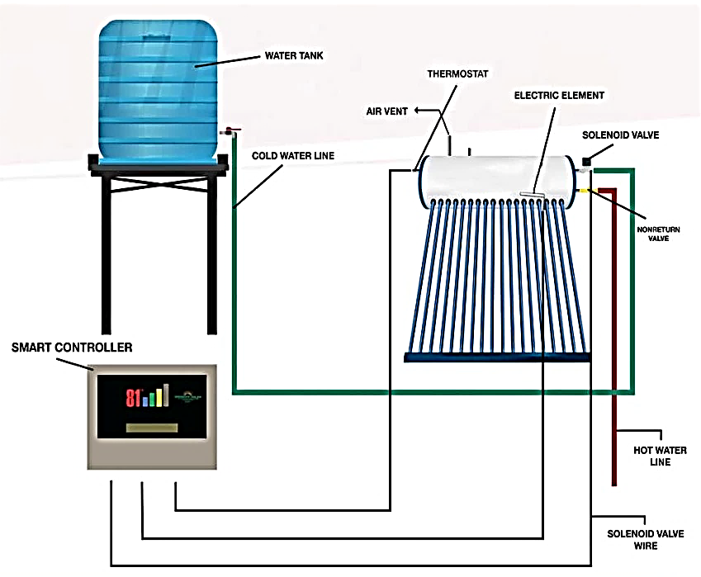
Prepared By:
Zeeshan Ahmad GTVC Dargai MKD
Muhammad Ibrar GTVC Mardan
Hot Water Storage Tank
Vacuum Tube Solar Collectors
Tube Holder
Annex: 1

Feedback to the Candidate
Candidate’s Signature__________________ Assessor’s Signature _________________

