Assessment Evidence Guide
For
“PLUMBER”
LEVEL-3
Summative Assessment

Date 04-09 November, 2024
Lahore


National Vocational & Technical
Training Commission

Instruction Sheet for the Candidate
Qualification | National Vocation Certificate “PLUMBER” LEVEL-3
Competency Standard | 0732BCE1601 Carry out safety precautions  0732BCE1602 Install sanitary accessories  0732BCE1603 Install pumps  0732BCE1604 Lay down drain system  0732BCE1605 Service of pipelines & sanitary installation  0732BCE1606 Install solar water heating system  0732BCE1607 Install Commercial Supply Pipe Lines  0732BCE1608 Perform Pipe Fabrication  0732BCE1609 Prepare Report & cost estimation
Purpose of Assessment | Summative Assessment
Candidate Details | Name______________________________________________________  Registration/Roll Number_______________________________________
Guidance for Candidate | To meet this standard, you are required to complete the following within 05 Hrs. time frame (for practical demonstration & assessment):  TASK A:  - Assemble the solar water heating system and install for domestic purpose, joint the outlet point for general use according to the given drawing. (Annex 1)  OR  TASK B:  - Install a double bathroom fitting as per below drawing. Also enlist & demand Tools, Equipments & Accessories etc to be used in this task. Use PPRC or GI Pipe. (Annex 2)
Time: 05 Hrs. | During a practical assessment, under observation by an assessor, you are required to
Minimum Evidence Required | TASK A:  - Perform all safety checks and wear appropriate PPEs.  - Perform estimation of household's hot water consumption  - Select the appropriate tools as per job requirements  - Measure, cut, and join pipes as per installation layout  - Connect solar collector and frame according to instructions  - Position the solar collector and connect to the storage tank.  - Ensure the solar water heater is installed at an angle that maximizes sun exposure  - Install essential sanitary accessories, including solenoid valves and connectors  - Inspect and clean pipelines and fittings  - Clean surface of the solar collector  - Check control system is functioning correctly.  - Prepare a cost estimation report for installation materials  TASK B:  - Perform all safety checks and wear appropriate PPEs.  - Read and Interpret Drawings for Accurate Placement.  - Select the appropriate tools as per job requirements  - Measure, cut, and join pipes as per installation layout  - Ensure Wash Basin Points are 24 Inches from the Floor  - Measure and Mark Shower Points as per Drawing  - Ensure Shower Points are 36 Inches from the Floor  - Ensure Shower Head Points are 86 Inches from the Floor  - Secure and leak proof connections for both hot and cold.  - Install English Water Closet as per Drawing  - Ensure Proper Slope (1:40 or as required) for Drainage Pipes.  - Join Pipes and Fittings Using Appropriate Techniques.

Self-Assessment Checklist
Candidate Name
Registration No.
Qualification | National Vocation Certificate PLUMBER LEVEL-3
Competency Standard | 0732BCE1601 Carry out safety precautions  0732BCE1602 Install sanitary accessories  0732BCE1603 Install pumps  0732BCE1604 Lay down drain system  0732BCE1605 Service of pipelines & sanitary installation  0732BCE1606 Install solar water heating system  0732BCE1607 Install Commercial Supply Pipe Lines  0732BCE1608 Perform Pipe Fabrication  0732BCE1609 Prepare Report & cost estimation
Purpose of Assessment | Summative Assessment
Assessment Task | TASK A:  - Assemble the solar water heating system and install for domestic purpose, joint the outlet point for general use according to the given drawing. (Annex 1)  OR  TASK B:  - Install a double bathroom fitting as per below drawing. Also enlist & demand Tools, Equipments & Accessories etc to be used in this task. Use PPRC or GI Pipe. (Annex 2)

I can……………….
Performance Criteria | Yes | No
TASK A:
- Perform all safety checks and wear appropriate PPEs.
- Perform estimation of household's hot water consumption
- Select the appropriate tools as per job requirements
- Measure, cut, and join pipes as per installation layout
- Connect solar collector and frame according to instructions
- Position the solar collector and connect to the storage tank.
- Ensure the solar water heater is installed at an angle that maximizes sun exposure
- Install essential sanitary accessories, including solenoid valves and connectors
- Inspect and clean pipelines and fittings
- Clean surface of the solar collector
- Check control system is functioning correctly.
- Prepare a cost estimation report for installation materials
TASK B:
- Perform all safety checks and wear appropriate PPEs.
- Read and Interpret Drawings for Accurate Placement.
- Select the appropriate tools as per job requirements
- Measure, cut, and join pipes as per installation layout
- Ensure Wash Basin Points are 24 Inches from the Floor
- Measure and Mark Shower Points as per Drawing
- Ensure Shower Points are 36 Inches from the Floor
- Ensure Shower Head Points are 86 Inches from the Floor
- Secure and leak proof connections for both hot and cold.
- Install English Water Closet as per Drawing
- Ensure Proper Slope (1:40 or as required) for Drainage Pipes.
- Join Pipes and Fittings Using Appropriate Techniques

Candidate’s Signature__________________ Assessor’s Signature____________________
Date: ______________________________

Assessors Judgment Guide
Qualification | National Vocation Certificate PLUMBER LEVEL 3
Competency Standard | 0732BCE1601 Carry out safety precautions  0732BCE1602 Install sanitary accessories  0732BCE1603 Install pumps  0732BCE1604 Lay down drain system  0732BCE1605 Service of pipelines & sanitary installation  0732BCE1606 Install solar water heating system  0732BCE1607 Install Commercial Supply Pipe Lines  0732BCE1608 Perform Pipe Fabrication  0732BCE1609 Prepare Report & cost estimation
Purpose of Assessment | Summative Assessment
Candidate Details | Name: ______________________________________________________________  Registration/Roll Number: ______________________Signature: _______________
Assessment Outcome | COMPETENT NOT YETCOMPETENT  Name of the Assessor________________________________________________  Assessor’s code: ____________________________________________________  Signature: ________________________________

Assessment Summary (to be filled by the assessor)
Activity | Method |  |  |  |  | Result
Nature of Activity | Written | Oral | Observation | Portfolio | Role Play | Competent | Not Yet Competent
Practical Skill Demonstration
Knowledge Assessment
Other Requirement

Observation Checklist
Assessment Task |  | TASK A:  - Assemble the solar water heating system and install for domestic purpose, joint the outlet point for general use according to the given drawing. (Annex 1)  OR  TASK B:  - Install a double bathroom fitting as per below drawing. Also enlist & demand Tools, Equipments & Accessories etc to be used in this task. Use PPRC or GI Pipe. (Annex 2)
During the practical assessment, candidate demonstrated the following: |  |  |  | Yes | No | Remarks
TASK A:
1 | Perform all safety checks and wear appropriate PPEs.
2 | Perform estimation of household's hot water consumption
3 | Select the appropriate tools as per job requirements
4 | Measure, cut, and join pipes as per installation layout
5 | Connect solar collector and frame according to instructions
6 | Position the solar collector and connect to the storage tank.
7 | Ensure the solar water heater is installed at an angle that maximizes sun exposure
8 | Install essential sanitary accessories, including solenoid valves and connectors
9 | Inspect and clean pipelines and fittings
10 | Clean surface of the solar collector
11 | Check control system is functioning correctly.
12 | Prepare a cost estimation report for installation materials
TASK B:

1 | Perform all safety checks and wear appropriate PPEs.
2 | Read and Interpret Drawings for Accurate Placement.
3 | Select the appropriate tools as per job requirements
4 | Measure, cut, and join pipes as per installation layout
5 | Ensure Wash Basin Points are 24 Inches from the Floor
6 | Measure and Mark Shower Points as per Drawing
7 | Ensure Shower Points are 36 Inches from the Floor
8 | Ensure Shower Head Points are 86 Inches from the Floor
9 | Secure and leak proof connections for both hot and cold.
10 | Install English Water Closet as per Drawing
11 | Ensure Proper Slope (1:40 or as required) for Drainage Pipes.
12 | Join Pipes and Fittings Using Appropriate Techniques
Competent |  |  | Not yet Competent

Knowledge Assessment
Qualification | National Vocation Certificate PLUMBER LEVEL 3
Competency Standard | 0732BCE1601 Carry out safety precautions  0732BCE1602 Install sanitary accessories  0732BCE1603 Install pumps  0732BCE1604 Lay down drain system  0732BCE1605 Service of pipelines & sanitary installation  0732BCE1606 Install solar water heating system  0732BCE1607 Install Commercial Supply Pipe Lines  0732BCE1608 Perform Pipe Fabrication  0732BCE1609 Prepare Report & cost estimation
Purpose of Assessment | Summative Assessment
Candidate Details | Name: ______________________________________________________________  Registration/Roll Number: _________________ Candidate Signature: ___________
Assessment Outcome | COMPETENT NOT YETCOMPETENT  Name of the Assessor: ________________________________________________  Assessor’s code: ____________________________________________________  Signature of the Assessor: _______________________

Candidate’s response is not required to be identical, but similar concepts and/or keywords must be used. Oral questioning may be used to clarify candidate understanding of topic and its application.

Questions (Candidate confidently answered questions correctly and demonstrated understanding of the topics and their application) |  |  | Satisfactory | Not Satisfactory
01 | Define the safety checks required before installation
02 | What is the function of a controller in a solar water heater system?
03 | Define a solenoid valve and its function in plumbing systems
04 | Define a collector tube and its role in a solar water heating system.
05 |  | Define solenoid valve.
06 |  | Write any 3 advantages of solar water heater.
07 |  | PPRC Stand for?
08 |  | GI Stand for?
09 |  | PVC Stand for?
10 |  | Define the proper slope for drainage pipes

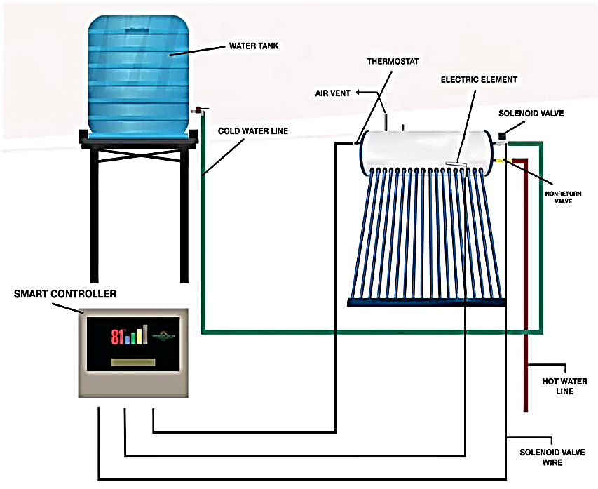
Prepared By:
Zeeshan Ahmad GTVC Dargai MKD
Muhammad Ibrar GTVC Mardan
Annex: 1
Tube Holder
Vacuum Tube Solar Collectors
Hot Water Storage Tank
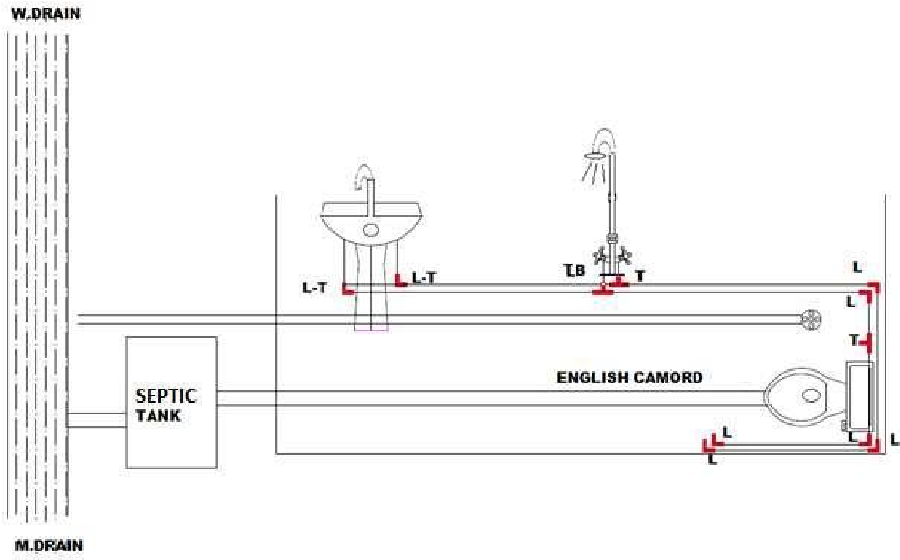
PVC Pipe
Double Shower
Wash Basin
English W.C
Annex: 2
Feedback to the Candidate
Candidate’s Signature__________________ Assessor’s Signature _________________

