Assessment Evidence Guide
For
Solar PV System Technician Level-2

(Summative Assessment)
Date: 04-09 November, 2024
Lahore

National Vocational & Technical Training Commission Islamabad

Instruction Sheet for the Candidate
Qualification | Solar PV System Technician
Competency Standard | Module 0713E&E3401: Follow Occupational Health and Safety practices  Module 0713E&E3402: Demonstrate Basic Communication Skills  Module 0713E&E3403: Apply Basic Electricity Concept  Module 0713E&E3404: Perform Single phase/three phase Electrical Wiring System  Module 0713E&E3405: Introduction to Solar PV System  Module 0713E&E3406: Design of Solar PV System  Module 0713E&E3407: Installation of Solar PV System  Module 0713E&E3408: Maintenance of Solar PV System  Module 0713E&E3409: Operation of Solar PV System
Purpose of Assessment | Summative Assessment
Candidate Details | Name______________________________________________________  Registration/Roll Number_______________________________________
Guidance for Candidate | The candidate is required to complete the given task by following the operational health and safety at workplace within time frame (for practical demonstration & assessment):  Task 1:  - Installation of Room Wiring according to the layout diagram  - Design and complete installation of Solar PV System according to the electrical load of room (Annex. 1)  (OR)  Task 2:  Design and install a Solar PV System of up to 5 KVA (Annex. 1)
Time: 05 Hrs. | During a practical assessment, under observation by an assessor, you are required to
Minimum Evidence Required | Task 1 (a):  - Put on Personal protective equipment (PPE) and appropriate clothing  - Identify & Handle tools and equipment according to the practical assessment task  - Select wiring materials and accessories according to the circuit diagram.  - Make the circuit on exercise board according to installation diagram.  - Install accessories according to layout diagram.  - Lay wires in duct/pipe according to layout diagram.  - Make connections according to wiring diagram.  - Check the open /short circuit & polarity Test before connection with the main supply.  - Make connection with the main supply.  - Check the function of circuit after connection with main supply.  Task 1 (b)  - Temporarily mount Solar PV modules (Panels) securely on specific site.  - Connect the solar PV modules in Series/Parallel based on system design.  - Install and wire the Hybrid Solar inverter, battery storage and charge controller according to the safety and regulatory standard.  - Make the connection of the WAPDA supply/Main supply with Hybrid solar invertor.  - Make the connection of the Load with Hybrid solar invertor  - Make the connection of Solar PV modules with Hybrid Solar Invertor according to the input voltage range of Hybrid Solar Invertor.  - Measure Voltage, Current, Power, of solar PV modules and Hybrid solar invertor with help of meters.  - Measure earth resistance of the earthing system.  (OR)  Task 2  - Put on Personal protective equipment (PPE) and appropriate clothing.  - Size Solar PV System including Solar PV Modules, Battery, Inverter and controller according to the system design of 5 KVA.  - Temporarily mount Solar PV Modules (Panels) securely on specific site.  - Set the direction and tilt angle of solar PV Modules.  - Connect the solar PV Modules in Series/ Parallel according to the system design.  - Install and wire the Hybrid Solar inverter, battery storage and charge controller according to the safety and regulatory standard.  - Make the connection of the WAPDA supply/Main supply with Hybrid solar invertor.  - Make the connection of the Load with Hybrid solar invertor  - Make the connection of Solar PV modules with Hybrid Solar Invertor according to the input voltage range of Hybrid Solar Invertor.  - Measure Voltage, Current, Power, of solar PV modules and Hybrid solar invertor with help of meters.

Self-Assessment Checklist
Candidate Name
Registration No.
Qualification | Solar PV System Technician
Competency Standard | Module 0713E&E3401: Follow Occupational Health and Safety practices  Module 0713E&E3402: Demonstrate Basic Communication Skills  Module 0713E&E3403: Apply Basic Electricity Concept  Module 0713E&E3404: Perform Single phase/three phase Electrical Wiring System  Module 0713E&E3405: Introduction to Solar PV System  Module 0713E&E3406: Design of Solar PV System  Module 0713E&E3407: Installation of Solar PV System  Module 0713E&E3408: Maintenance of Solar PV System  Module 0713E&E3409: Operation of Solar PV System
Purpose of Assessment | Summative Assessment
Assessment Task | The candidate is required to complete the given task by following the operational health and safety at workplace within time frame (for practical demonstration & assessment):  Task 1:  - Installation of Room Wiring according to the layout diagram  - Design and complete installation of Solar PV System according to the electrical load of room (Annex. 1)  (OR)  Task 2:  Design and install a Solar PV System of up to 5 KVA (Annex. 1)

I can……………….
Performance Criteria | Yes | No
Task 1 (a)
- Put on Personal protective equipment (PPE) and clothing.
- Identify and handle tools and equipment according to the practical assessment task.
- Select wiring materials and accessories according to the circuit diagram.
- Make the circuit on exercise board according to installation diagram.
- Install accessories according to layout diagram.
- Lay wires in duct/pipe according to layout diagram.
- Make connections according to wiring diagram.
- Check the open /short circuit & polarity Test before connection with the main supply.
- Make connection with the main supply.
- Check the function of circuit after connection with main supply.
Task 1 (b)
- Temporary mount the Solar PV Modules
- Connect the solar PV modules in series/Parallel.
- Make the connection of the battery with the Hybrid solar invertor.
- Make the connection of the solar PV modules with Hybrid solar invertor according to the input operating voltage range of solar invertor.
- Make the connection of the WAPDA supply/Main supply with Hybrid solar invertor.
- Make the connection of the Load with Hybrid solar invertor
- Measure Voltage, Current, Power, of solar PV modules and Hybrid solar invertor with help of meters.
- Measure earth resistance of the earthing system.
(OR)
Task 2
- Put on Personal protective equipment (PPE) and appropriate clothing.
- Size Solar PV System including Solar PV Modules, Battery, Inverter and controller according to the system design of 5 KVA.
- Temporarily mount Solar PV Modules (Panels) securely on specific site.
- Set the direction and tilt angle of solar PV Modules.
- Connect the solar PV Modules in Series/ Parallel according to the system design.
- Install and wire the Hybrid Solar inverter, battery storage
and charge controller according to the safety and regulatory
standard.
- Make the connection of the WAPDA supply/Main supply with Hybrid solar invertor.
- Make the connection of the Load with Hybrid solar invertor
- Make the connection of Solar PV modules with Hybrid Solar Invertor according to the input voltage range of Hybrid Solar Invertor.
- Measure Voltage, Current, Power, of solar PV modules and Hybrid solar invertor with help of meters.

Candidate’s Signature__________________ Assessor’s Signature____________________
Date: _______________________________

Assessors Judgment Guide
Qualification | Solar PV System Technician
Competency Standard | Module 0713E&E3401: Follow Occupational Health and Safety practices  Module 0713E&E3402: Demonstrate Basic Communication Skills  Module 0713E&E3403: Apply Basic Electricity Concept  Module 0713E&E3404: Perform Single phase/three phase Electrical Wiring System  Module 0713E&E3405: Introduction to Solar PV System  Module 0713E&E3406: Design of Solar PV System  Module 0713E&E3407: Installation of Solar PV System  Module 0713E&E3408: Maintenance of Solar PV System  Module 0713E&E3409: Operation of Solar PV System
Purpose of Assessment | Summative Assessment
Candidate Details | Name: ______________________________________________________________  Registration/Roll Number: ______________________ Signature: _______________
Assessment Outcome | COMPETENT NOT YET COMPETENT  Name of the Assessor________________________________________________  Assessor’s code:____________________________________________________  Signature: ________________________________

Assessment Summary (to be filled by the assessor)
Activity | Method |  |  |  |  | Result
Nature of Activity | Written | Oral | Observation | Portfolio | Role Play | Competent | Not Yet Competent
Practical Skill Demonstration
Knowledge Assessment
Other Requirement

Observation Checklist
Assessment Task |  | The candidate is required to complete the given task by following the operational health and safety at workplace within time frame (for practical demonstration & assessment):  Task 1:  - Installation of Room Wiring according to the layout diagram  - Design and complete installation of Solar PV System according to the electrical load of room (Annex. 1)  (OR)  Task 2:  Design and install a Solar PV System of up to 5 KVA (Annex. 1)
During the practical assessment, candidate demonstrated the following: |  |  |  | Yes | No | Remarks
Task 1 (a)
 | Put on Personal protective equipment (PPE) and clothing.
 | Identify & handle tools and equipment according to the practical assessment task
 | Select wiring materials and accessories according to the circuit diagram.
 | Make the circuit on exercise board according to installation diagram.
 | Install accessories according to layout diagram.
 | Lay wires in duct/pipe according to layout diagram.
 | Make connections according to wiring diagram.
 | Check the open /short circuit & polarity Test before connection with the main supply.
 | Make connection with the main supply.
 | Check the function of circuit after connection with main supply.
Task 1 (b)
1. | Temporary mount the Solar PV Modules
2. | Connect the solar PV modules in series/Parallel.
3. | Make the connection of the battery with the Hybrid solar invertor.
4. | Make the connection of the solar PV modules with Hybrid solar invertor according to the input operating voltage range of solar invertor.
5. | Make the connection of the WAPDA supply/Main supply with Hybrid solar invertor.
6. | Make the connection of the Load with Hybrid solar invertor
7. | Measure Voltage, Current, Power, of solar PV modules and Hybrid solar invertor with help of meters.
8. | Measure earth resistance of the earthing system.
(OR) Task 2
1. | Put on Personal protective equipment (PPE) and appropriate clothing.
2. | Size Solar PV System including Solar PV Modules, Battery, Inverter and controller according to the system design of 5 KVA.
3. | Temporarily mount Solar PV Modules (Panels) securely on specific site.
4. | Set the direction and tilt angle of solar PV Modules.
5. | Connect the solar PV Modules in Series/ Parallel according to the system design.
6. | Install and wire the Hybrid Solar inverter, battery storage and charge controller according to the safety and regulatory standard.
7. | Make the connection of the WAPDA supply/Main supply with Hybrid solar invertor.
8. | Make the connection of the Load with Hybrid solar invertor
9. | Make the connection of Solar PV modules with Hybrid Solar Invertor according to the input voltage range of Hybrid Solar Invertor.
10. | Measure Voltage, Current, Power, of solar PV modules and Hybrid solar invertor with help of meters.
Competent |  |  | Not Yet Competent

Knowledge Assessment
Qualification | 0713E&E34 Solar PV System Technician _Level-2
Competency Standard | Module 0713E&E3401: Follow Occupational Health and Safety practices  Module 0713E&E3402: Demonstrate Basic Communication Skills  Module 0713E&E3403: Apply Basic Electricity Concept  Module 0713E&E3404: Perform Single phase/three phase Electrical Wiring System  Module 0713E&E3405: Introduction to Solar PV System  Module 0713E&E3406: Design of Solar PV System  Module 0713E&E3407: Installation of Solar PV System  Module 0713E&E3408: Maintenance of Solar PV System  Module 0713E&E3409: Operation of Solar PV System
Purpose of Assessment | Summative Assessment
Candidate Details | Name: ______________________________________________________________  Registration/Roll Number: _________________ Candidate Signature:___________
Assessment Outcome | COMPETENT NOT YET COMPETENT  Name of the Assessor: ________________________________________________  Assessor’s code: ____________________________________________________  Signature of the Assessor:_______________________

Candidate’s response is not required to be identical, but similar concepts and/or keywords must be used. Oral questioning may be used to clarify candidate understanding of topic and its application.

Questions (Candidate confidently answered questions correctly and demonstrated understanding of the topics and their application) |  | Satisfactory | Not Satisfactory
 | What is the difference between series and parallel connection?
 | Write down different types of Solar PV Modules?
 | Describe the function of charge controller?
 | What is MPPT?
 | What is meant by dry battery?
 | What is earthing in Solar PV System?
 | What is DC Earthing?
 | What is AC Earthing?
 | Explain the function of On-Grid System?
 | What is Off-Grid System?

Feedback to the Candidate
Candidate’s Signature__________________ Assessor’s Signature _________________

Task 1
(Annex. 1)
- Installation of Room Wiring according to the layout diagram
- Design and complete installation of Solar PV System according to the electrical load of room
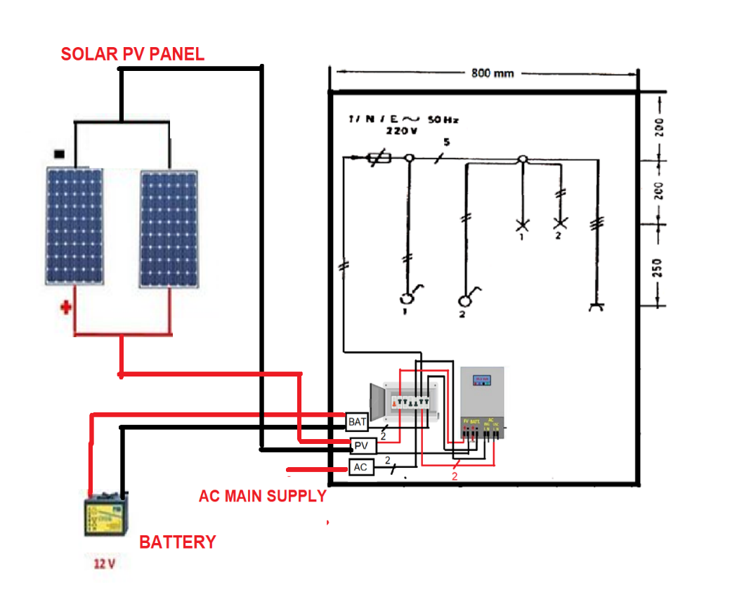

(OR)

Task 2
(Annex. 1)
Design and install a Solar PV System of up to 5 KVA.
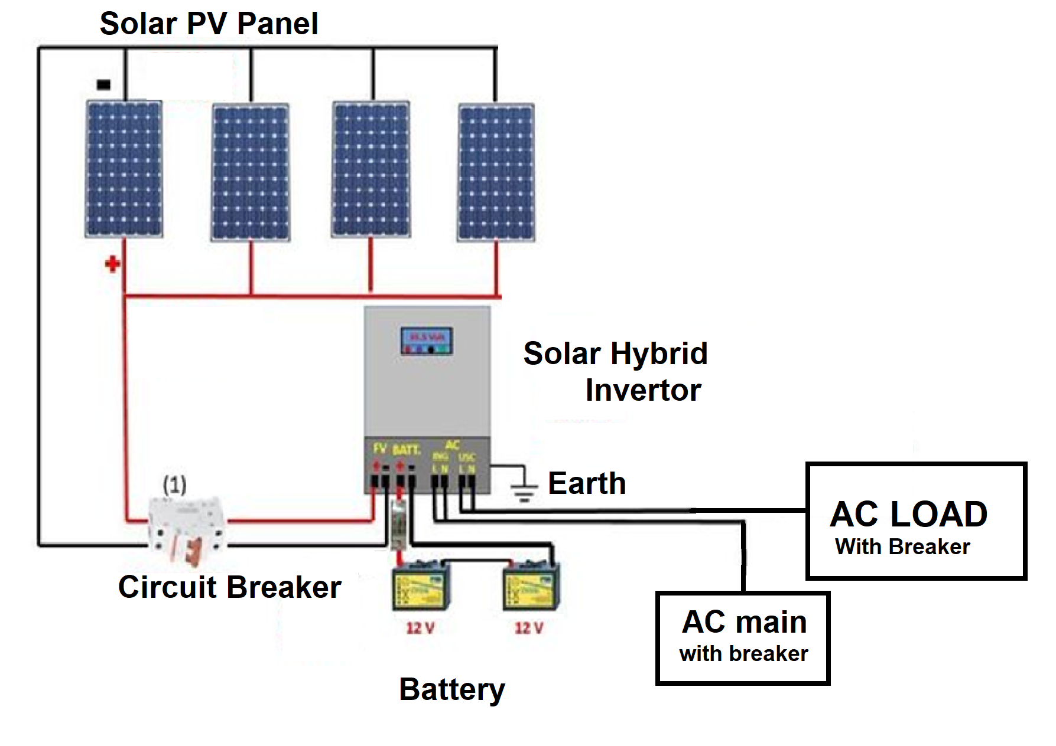

Tools, Equipment Required
The tools and equipment required for this competency standard are provided below:
SR. NO | NAME | QTY. REQUIRED
1 | Safety shoes | 10
2 | Safety goggles | 10
3 | Safety Helmet | 25
4 | Safety Belt | 05
5 | First Aid Box | 1
6 | Fire Extinguisher | 02
7 | AVO Meter | 05
8 | Combination Plier. | 25
9 | Nose plier. | 25
10 | Wire Stripper | 25
11 | Soldering Iron | 05
12 | Set of Screw Drivers | 25
13 | Ring Spanner Set | 02
14 | Tacho Meter-Digital | 02
15 | Earth resistance tester (Digital) | 02
16 | Continuity & Insulation tester | 02
17 | IR Temperature Gun | 02
18 | Digital Multimeter | 05
19 | Cable Knife | 25
20 | Phase Sequence Meter | 02
21 | Clamp-On Meter (AC &DC) | 05
22 | Lux Meter | 02
23 | Lugs Punching Machine (Hydraulic and Manual) | 01
24 | Battery Tester | 02
25 | Micro Meter mm | 03
26 | Hydrometer | 05
27 | Disk Grinder Machine | 02
28 | Hammer | 05
29 | Hacksaw cutter | 05
30 | Battery Charger | 02
31 | Bench Vice | 02
32 | Chisel | 02
33 | Digital Oscilloscope | 01
34 | 3- Phase energy meter (Green Meter) | 01
35 | Energy meter Digital Single Phase | 03
36 | Charge Controller PWM 40 amp | 01
37 | Charge Controller MPPT 50 amp | 01
38 | Solar Hybrid Inverter 4KW MPPT | 01
39 | Solar Hybrid Inverter 6KW MPPT | 01
40 | Solar OFF-Grid Inverter MPPT 3KW | 01
41 | Solar ON-Grid Inverter MPPT 10 KKW | 01
42 | Inverter 1500-watt sine wave | 02
43 | Lead Acid Battery -12 V, 150 AH | 04
44 | DRY Battery- 12 V, 100AH | 02
45 | Tall tubular Battery -12 V, 180AH | 02
46 | Solar PV Module Mono PERC Half Cut P-Type, 580 W | 10
47 | Solar PV Module Mono PERC Half Cut N-Type, 580 W | 10
48 | Solar panel monocrystalline | 02
49 | Solar panel thin film | 02
50 | DC power Supply 12-to-24-volt | 01
51 | Solar panel Structure (L2, L3) | 10
52 | Solar PV Tester | 01
53 | Three Phase Induction Motor | 01
54 | Voltmeter (Analog & Digital) | 05
55 | Ampere Meter (Analog & Digital) | 05
56 | Watt Meter (Analog & Digital) | 02
57 | VAR Meter | 02
58 | Digital Power Factor Meter | 02
59 | Analog Multimeter | 02
60 | Energy meter Digital- Three phase | 01
61 | Safety gloves with leather upper cover (pair) | 10
62 | Spanner set (Open end) | 02
63 | Ratcheted Set | 02
64 | SWG Wire Gage | 05
65 | Level | 05
66 | Screw Driver Set Cardless (battery operated) | 01
67 | Printer | 01
68 | Computer | 03
69 | Multimedia Projector | 01
70 | Rotary Change Over 2P 50A | 2
71 | Rotary Change Over 4P 100A | 2
72 | Electronic Relay 0-20Amp | 2

