Assessment Evidence Guide
For
National Vocational Certificate in Welder Level-2
Formative Assessment
0715MMT3704 - Prepare Material for Welding
Date 04th – 09th November, 2024
Lahore


National Vocational & Technical
Training Commission

Instruction Sheet for the Candidate
Qualification | National Vocational Certificate in Welder Level-2
Competency Standard | 0715MMT3704 - Prepare Material for Welding
Purpose of Assessment | Formative Assessment
Candidate Details | Name______________________________________________________  Registration/Roll Number_______________________________________
Guidance for Candidate | - Measure and Mark Materials as per Drawing / Job Requirement.  - Cut and Prepare Edges of Base Materials.  - Prepare Welding Consumables as per Job Requirement.  - Fit-up Base Materials as per Job Requirement  Activity: Tack single “V” Butt joint as per the below diagram  dimensions. (See Annex - A)
Time: 4 Hrs. | During a practical assessment, under observation by an assessor, you are required to
Minimum Evidence Required | - Select and obtain required material/s as per job.  - Select correct measuring tools as per job requirements  - Mark the area to be cut as per drawing / job requirements.  - Cut the base material as per job specifications and dimensions provided in the drawing.  - Clean the edges of the base materials as per job requirements.  - Select correct welding consumables as per job requirements / WPS.  - Dispose Defective Consumables in accordance with green practices i.e. Recycle, Reuse defective metal pieces.  - Verify root gap as per drawing / welding procedure Specifications (WPS  - The tack welds should be uniform in length, height, and width, as per the specified drawing dimensions.  - Tack welds should hold the joint without causing distortion or misalignment.  - Tack weld joint/s as per drawing / welding procedure Specifications (WPS).
Self-Assessment Checklist
Candidate Name
Registration No.
Qualification | National Vocational Certificate in Welder Level-2
Competency Standard | 0715MMT3704 - Prepare Material for Welding
Purpose of Assessment | Formative Assessment
Assessment Task | - Measure and Mark Material/s as per Drawing / Job Requirement.  - Cut and Prepare Edge/s of Base Materials  - Prepare Welding Consumables as per Job Requirement  - Fit-up Base Materials as per Job Requirement  Activity: Tack single “V” Butt joint as per the below  diagram dimensions. (See Annex-A)
I can……………….
Performance Criteria | Yes | No
1.Select and obtain required material/s as per job.
2.Select correct measuring tools as per job requirements
3.Mark the area to be cut as per drawing / job requirements.
4.Cut the base material as per job specifications and dimensions provided in the drawing.
5.Clean the edges of the base materials as per job requirements.
6.Select correct welding consumables as per job requirements / WPS.
7.Dispose Defective Consumables in accordance with green practices i.e. Recycle, Reuse defective metal pieces.
8.Verify root gap as per drawing / welding procedure Specifications (WPS).
9.The tack welds should be uniform in length, height, and width, as per the specified drawing dimensions.
10. Tack welds should hold the joint without causing distortion or misalignment
11.Tack weld joint/s as per drawing / welding procedure Specifications (WPS).

Candidate’s Signature__________________ Assessor’s Signature____________________

Date: _______________________________
Annex-A

Diagram (Single “V” Butt Joint)

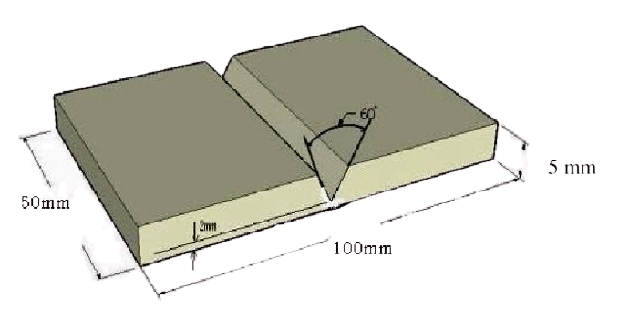

Assessors Judgment Guide
Qualification | National Vocational Certificate in Welder Level-2
Competency Standard | 0715MMT3704 - Prepare Material for Welding
Purpose of Assessment | Formative Assessment
Candidate Details | Name: ______________________________________________________________  Registration/Roll Number: ______________________ Signature: _______________
Assessment Outcome | COMPETENT NOT YET COMPETENT  Name of the Assessor________________________________________________  Assessor’s code: ____________________________________________________  Signature: ________________________________

Assessment Summary (to be filled by the assessor)
Activity | Method |  |  |  |  | Result
Nature of Activity | Written | Oral | Observation | Portfolio | Role Play | Competent | Not Yet Competent
Practical Skill Demonstration
Knowledge Assessment
Other Requirement

Observation Checklist
Assessment Task |  | - Measure and Mark Material/s as per Drawing / Job Requirement.  - Cut and Prepare Edge/s of Base Materials  - Prepare Welding Consumables as per Job Requirement  - Fit-up Base Materials as per Job Requirement  Activity: Tack single “V” Butt joint as per the below  diagram dimensions. (See Annex-A)
During the practical assessment, candidate demonstrated the following: |  |  |  | Yes | No | Remarks
 | Select and obtain required material/s as per job.
 | Select correct measuring tools as per job requirements
 | Mark the area to be cut as per drawing / job requirements.
 | Cut the base material as per job specifications and dimensions provided in the drawing.
 | Clean the edges of the base materials as per job requirements.
 | Select correct welding consumables as per job requirements / WPS.
 | Dispose Defective Consumables in accordance with green practices i.e. Recycle, Reuse defective metal pieces.
 | Verify root gap as per drawing / welding procedure Specifications (WPS).
 | The tack welds should be uniform in length, height, and width, as per the specified drawing dimensions.
 | Tack welds should hold the joint without causing distortion or misalignment
 | Tack weld joint/s as per drawing / welding procedure Specifications (WPS).
Competent |  |  | Not Yet Competent

Knowledge Assessment
Qualification | National Vocational Certificate in Welder Level-2
Competency Standard | 0715MMT3704 - Prepare Material for Welding
Purpose of Assessment | Formative Assessment
Candidate Details | Name: ______________________________________________________________  Registration/Roll Number: _________________ Candidate Signature: ___________
Assessment Outcome | COMPETENT NOT YET COMPETENT  Name of the Assessor: ________________________________________________  Assessor’s code: ____________________________________________________  Signature of the Assessor: _______________________

Candidate’s response is not required to be identical, but similar concepts and/or keywords must be used. Oral questioning may be used to clarify candidate understanding of topic and its application.

 | Questions (Candidate confidently answered questions correctly and demonstrated understanding of the topics and their application) |  | Satisfactory | Not Satisfactory
 |  | Define Marking Tools.
 |  | Define Cutting Tools.
 |  | Define the Consumable Material.
 |  | Define the Measuring Tools.
 |  | 1” = …………. Cm?
Feedback to the Candidate
Candidate’s Signature__________________ Assessor’s Signature _________________

