Assessment Evidence Guide
For
National Vocational Certificate in Welder
Level-2
Summative Assessment

Date 04th - 09th November, 2024
Lahore

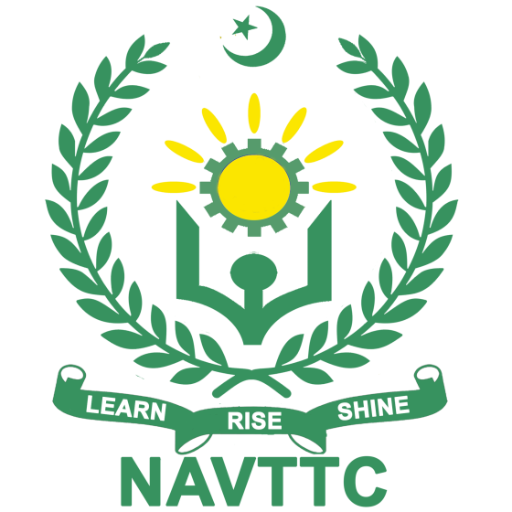
National Vocational & Technical
Training Commission

Instruction Sheet for the Candidate
Qualification | National Vocational Certificate in Welder Level 02
Competency Standard | - 0715MMT3701 Introduction to Work Ethics  - 0715MMT3702 Perform Basic Communication Skills  - 0715 MMT3703 Maintain Safety at Workplace  - 0715 MMT3704 Prepare Materials for Welding  - 0715 MMT3705 Carry Out Gas Welding and Gas Cutting Operations  - 0715 MMT3706 Carry Out Shielded Metal Arc Welding (SMAW) in  different Positions  - 0715 MMT3707 Carry Out Gas Metal Arc Welding (GMAW) in  different Positions  - 0715 MMT3708 Carry Out Gas Tungsten Arc Welding (GTAW) in  different Positions  - 0715 MMT3709 Carry out Flux Cored Arc Welding (FCAW) in Flat  (1F, 1G) and Horizontal (2F, 2G) Positions  - 0715 MMT3710 Carry Out Submerged Arc Welding (SAW)  - 0715 MMT3711 Develop entrepreneurship skills
Purpose of Assessment | Summative Assessment
Candidate Details | Name______________________________________________________  Registration/Roll Number_______________________________________
Guidance for Candidate | To meet this standard, you are required to complete the following within 05 Hrs. time frame (for practical demonstration & assessment):  Activity-01:  Perform Gas Welding on Lap / T – joint  (Material: M.S Plate, Size: 200mm x 25mm x 3mm) (See Annex-1)
Time: 05 Hrs. | During a practical assessment, under observation by an assessor, you are required to
Minimum Evidence Required | Activity 01:  Perform Gas Welding on Lap / T – joint  (Material: M.S Plate, Size: 200mm x 25mm x 3mm)  - Selects the correct M.S. plates (200mm x 25mm x 3mm) and ensures they meet specifications.  - Fit up the plates in the correct position for a Lap or T-joint configuration as per task instructions.  - Use fixtures for base materials to prevent movement during welding, ensuring accurate alignment and joint stability.  - Prepares the gas welding equipment by selecting appropriate torch tips, adjusting flame settings, and ensuring the correct gas pressure according to the plate thickness.  - Apply required PPE’s and follow other safety precautions for safe welding process.  - Adjusts the gas torch to achieve a neutral flame suitable for M.S. plate welding.  - Maintains a consistent distance and angle between the torch and the material to avoid excessive heat buildup or undercutting.  - Initiates the weld at the correct starting point, progressing in a smooth and controlled manner along the joint.  - Uses a steady and consistent weaving or circular motion as required, achieving even heat distribution and penetration across the joint.  - Ensures adequate penetration and fusion between the plates, with no visible gaps or separation.  - Maintains consistent bead width, height, and reinforcement along the joint for structural integrity.  - Inspects the completed joint for structural soundness, uniformity, and smoothness.  - Removes any slag or oxide layers to reveal a clean weld finish.  - Identifies any weld defects and, if necessary, repair the weld to meet quality standards.  - Cleans the workspace and stores all equipment and materials properly, following safety and maintenance procedures.

Self-Assessment Checklist
Candidate Name
Registration No.
Qualification | National Vocational Certificate in Welder Level-02
Competency Standard | - 0715MMT3701 Introduction to Work Ethics  - 0715MMT3702 Perform Basic Communication Skills  - 0715 MMT3703 Maintain Safety at Workplace  - 0715 MMT3704 Prepare Materials for Welding  - 0715 MMT3705 Carry Out Gas Welding and Gas Cutting  Operations  - 0715 MMT3706 Carry Out Shielded Metal Arc Welding  (SMAW) in different Positions  - 0715 MMT3707 Carry Out Gas Metal Arc Welding (GMAW) in  different Positions  - 0715 MMT3708 Carry Out Gas Tungsten Arc Welding (GTAW)  in different Positions  - 0715 MMT3709 Carry out Flux Cored Arc Welding (FCAW) in  Flat (1F, 1G) and Horizontal (2F, 2G) Positions  - 0715 MMT3710 Carry Out Submerged Arc Welding (SAW)  - 0715 MMT3711 Develop entrepreneurship skills
Purpose of Assessment | Summative Assessment
Assessment Task | Activity -01:  Perform Gas Welding on Lap / T – joint  (Material: M.S Plate, Size: 200mm x 25mm x 3mm)  (See Annex-1)

I can……………….
Performance Criteria (Activity -1) | Yes | No
- Selects the correct M.S. plates (200mm x 25mm x 3mm) and ensures they meet specifications.
- Fit up the plates in the correct position for a Lap or T-joint configuration as per task instructions.
- Use fixtures for base materials to prevent movement during welding, ensuring accurate alignment and joint stability.
- Prepares the gas welding equipment by selecting appropriate torch tips, adjusting flame settings, and ensuring the correct gas pressure according to the plate thickness.
- Apply required PPE’s and follow other safety precautions for safe welding process.
- Adjusts the gas torch to achieve a neutral flame suitable for M.S. plate welding.
- Maintains a consistent distance and angle between the torch and the material to avoid excessive heat buildup or undercutting.
- Initiates the weld at the correct starting point, progressing in a smooth and controlled manner along the joint.
- Uses a steady and consistent weaving or circular motion as required, achieving even heat distribution and penetration across the joint.
- Ensures adequate penetration and fusion between the plates, with no visible gaps or separation.
- Maintains consistent bead width, height, and reinforcement along the joint for structural integrity.
- Inspects the completed joint for structural soundness, uniformity, and smoothness.
- Removes any slag or oxide layers to reveal a clean weld finish.
- Identifies any weld defects and, if necessary, repair the weld to meet quality standards.
- Cleans the workspace and stores all equipment and materials properly, following safety and maintenance procedures.

Candidate’s Signature__________________ Assessor’s Signature____________________

Date: ______________________________

Assessors Judgment Guide
Qualification | National Vocational Certificate in Welder Level 02
Competency Standard | - 0715MMT3701 Introduction to Work Ethics  - 0715MMT3702 Perform Basic Communication Skills  - 0715 MMT3703 Maintain Safety at Workplace  - 0715 MMT3704 Prepare Materials for Welding  - 0715 MMT3705 Carry Out Gas Welding and Gas Cutting  Operations  - 0715 MMT3706 Carry Out Shielded Metal Arc Welding  (SMAW) in different Positions  - 0715 MMT3707 Carry Out Gas Metal Arc Welding (GMAW) in  different Positions  - 0715 MMT3708 Carry Out Gas Tungsten Arc Welding (GTAW)  in different Positions  - 0715 MMT3709 Carry out Flux Cored Arc Welding (FCAW) in  Flat (1F, 1G) and Horizontal (2F, 2G) Positions  - 0715 MMT3710 Carry Out Submerged Arc Welding (SAW)  - 0715 MMT3711 Develop entrepreneurship skills
Purpose of Assessment | Summative Assessment
Candidate Details | Name: ______________________________________________________________  Registration/Roll Number: ______________________Signature: _______________
Assessment Outcome | COMPETENT NOT YETCOMPETENT  Name of the Assessor________________________________________________  Assessor’s code: ____________________________________________________  Signature: ________________________________

Assessment Summary (to be filled by the assessor)
Activity | Method |  |  |  |  | Result
Nature of Activity | Written | Oral | Observation | Portfolio | Role Play | Competent | Not Yet Competent
Practical Skill Demonstration
Knowledge Assessment
Other Requirement

Observation Checklist
Assessment Task |  | Activity -01:  Perform Gas Welding on Lap / T – joint  (Material: M.S Plate, Size: 200mm x 25mm x 3mm) (See Annex-1)
During the practical assessment, candidate demonstrated the following: (Activity -1) |  |  |  | Yes | No | Remarks
 | Selects the correct M.S. plates (200mm x 25mm x 3mm) and ensures they meet specifications.
 | Fit up the plates in the correct position for a Lap or T-joint configuration as per task instructions.
 | Use fixtures for base materials to prevent movement during welding, ensuring accurate alignment and joint stability.
 | Prepares the gas welding equipment by selecting appropriate torch tips, adjusting flame settings, and ensuring the correct gas pressure according to the plate thickness.
 | Apply required PPE’s and follow other safety precautions for safe welding process.
 | Adjusts the gas torch to achieve a neutral flame suitable for M.S. plate welding.
 | Maintains a consistent distance and angle between the torch and the material to avoid excessive heat buildup or undercutting.
 | Initiates the weld at the correct starting point, progressing in a smooth and controlled manner along the joint.
 | Uses a steady and consistent weaving or circular motion as required, achieving even heat distribution and penetration across the joint.
 | Ensures adequate penetration and fusion between the plates, with no visible gaps or separation.
 | Maintains consistent bead width, height, and reinforcement along the joint for structural integrity.
 | Inspects the completed joint for structural soundness, uniformity, and smoothness.
 | Removes any slag or oxide layers to reveal a clean weld finish.
 | Identifies any weld defects and, if necessary, repair the weld to meet quality standards.
 | Cleans the workspace and stores all equipment and materials properly, following safety and maintenance procedures.
Competent |  |  | Not yet Competent
Knowledge Assessment
Qualification | National Vocational Certificate in Welder Level 02
Competency Standard | - 0715MMT3701 Introduction to Work Ethics  - 0715MMT3702 Perform Basic Communication Skills  - 0715 MMT3703 Maintain Safety at Workplace  - 0715 MMT3704 Prepare Materials for Welding  - 0715 MMT3705 Carry Out Gas Welding and Gas Cutting  Operations  - 0715 MMT3706 Carry Out Shielded Metal Arc Welding  (SMAW) in different Positions  - 0715 MMT3707 Carry Out Gas Metal Arc Welding (GMAW) in  different Positions  - 0715 MMT3708 Carry Out Gas Tungsten Arc Welding (GTAW)  in different Positions  - 0715 MMT3709 Carry out Flux Cored Arc Welding (FCAW) in  Flat (1F, 1G) and Horizontal (2F, 2G) Positions  - 0715 MMT3710 Carry Out Submerged Arc Welding (SAW)  - 0715 MMT3711 Develop entrepreneurship skills
Purpose of Assessment | Summative Assessment
Candidate Details | Name: ______________________________________________________________  Registration/Roll Number: _________________ Candidate Signature: ___________
Assessment Outcome | COMPETENT NOT YETCOMPETENT  Name of the Assessor: ________________________________________________  Assessor’s code: ____________________________________________________  Signature of the Assessor: _______________________

Candidate’s response is not required to be identical, but similar concepts and/or keywords must be used. Oral questioning may be used to clarify candidate understanding of topic and its application.

 | Questions (Candidate confidently answered questions correctly and demonstrated understanding of the topics and their application) |  | Satisfactory | Not Satisfactory
 |  | What is Work Ethics?
 |  | Name two common hazards in welding and how to avoid them?
 |  | Name two types of flames and their uses in gas welding.
 |  | Why is shielding gas used in GMAW?
 |  | What are the main differences between FCAW and GMAW?
Feedback to the Candidate
Candidate’s Signature__________________ Assessor’s Signature _________________

(Annex-1)

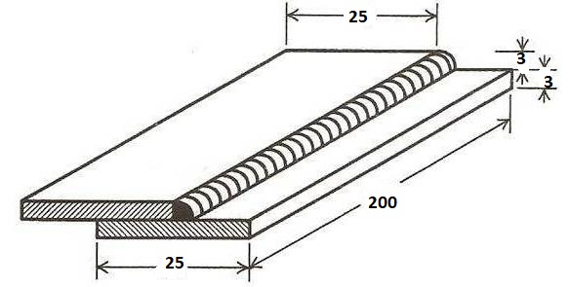

LAP Joint

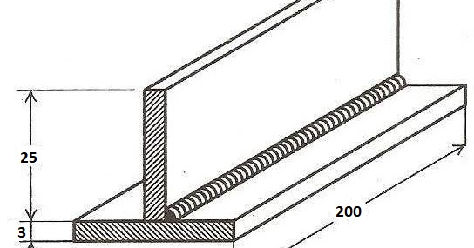

T –Joint

